**LAB 8**

Tên: Trần Đức

MSSV:1150080131

Bảng Sách

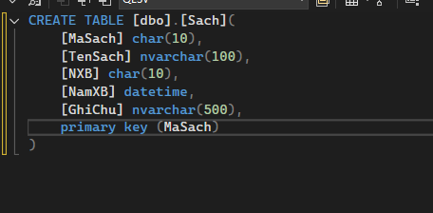

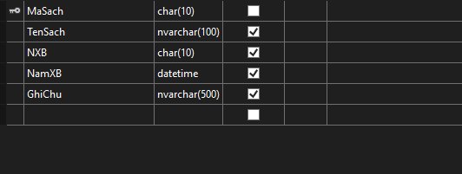

Bảng Nhà Xuất Bản

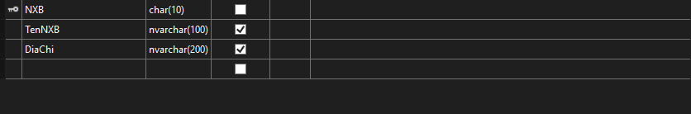

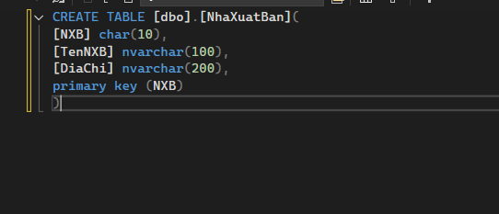

Thêm dữ liệu và liên kết 2 bảng

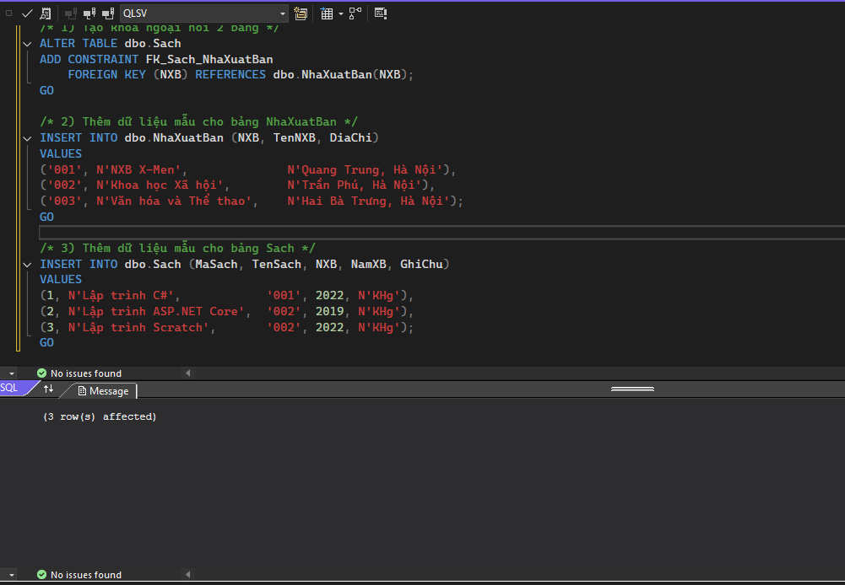

**Thực hành 1: Hiển thị danh sách nhà xuất bản sách.**

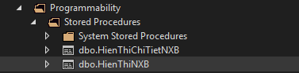

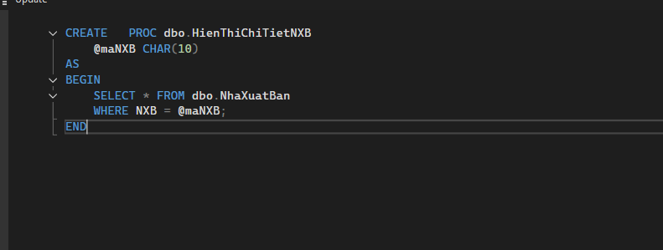

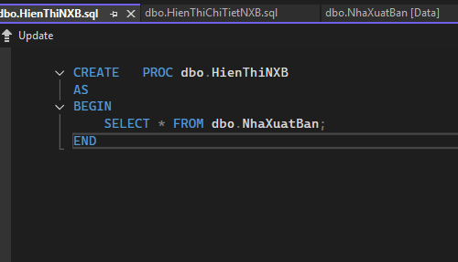

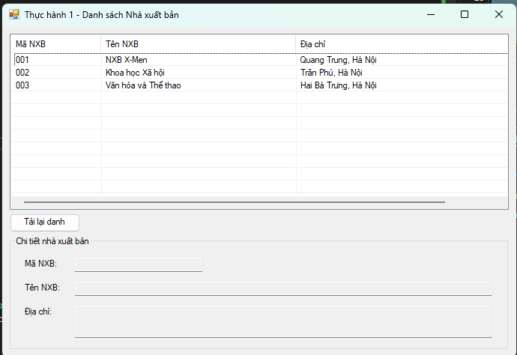

**Form1.cs**

using System;

using System.Data;

using System.Data.SqlClient;

using System.Windows.Forms;

namespace _1150080131_TranDuc_Lab6

{

public partial class Form1 : Form

{

private readonly string _connStr =

@"Data Source=LAPTOP-LQGGA8E3\MSSQLSERVER2;

Initial Catalog=QLSV;

Integrated Security=True;

Encrypt=True;

TrustServerCertificate=True;";

private SqlConnection _conn;

public Form1()

{

InitializeComponent();

}

private void OpenConn()

{

if (_conn == null) _conn = new SqlConnection(_connStr);

if (_conn.State != ConnectionState.Open) _conn.Open();

}

private void CloseConn()

{

if (_conn != null && _conn.State == ConnectionState.Open) _conn.Close();

}

private void Form1_Load(object sender, EventArgs e)

{

TryLoadNXB();

}

private void btnRefresh_Click(object sender, EventArgs e)

{

TryLoadNXB();

}

private void TryLoadNXB()

{

try

{

LoadNXB();

}

catch (Exception ex)

{

MessageBox.Show("Không thể tải danh sách NXB:\n" + ex.Message,

"Lỗi", MessageBoxButtons.OK, MessageBoxIcon.Error);

}

}

private void LoadNXB()

{

OpenConn();

using (var cmd = new SqlCommand("HienThiNXB", _conn))

{

cmd.CommandType = CommandType.StoredProcedure;

using (var rd = cmd.ExecuteReader())

{

lsvDanhSach.Items.Clear();

while (rd.Read())

{

// Giả sử proc trả: MaNXB (0), TenNXB (1), DiaChi (2)

string ma = rd.GetString(0).Trim();

string ten = rd.GetString(1);

string diachi = rd.GetString(2);

var item = new ListViewItem(ma);

item.SubItems.Add(ten);

item.SubItems.Add(diachi);

lsvDanhSach.Items.Add(item);

}

}

}

CloseConn();

ClearDetail();

}

private void lsvDanhSach_SelectedIndexChanged(object sender, EventArgs e)

{

if (lsvDanhSach.SelectedItems.Count == 0) return;

string ma = lsvDanhSach.SelectedItems[0].SubItems[0].Text;

ShowNXBById(ma);

}

private void ShowNXBById(string maNXB)

{

try

{

OpenConn();

using (var cmd = new SqlCommand("HienThiChiTietNXB", _conn))

{

cmd.CommandType = CommandType.StoredProcedure;

cmd.Parameters.Add(new SqlParameter("@maNXB", SqlDbType.Char, 10) { Value = maNXB });

using (var rd = cmd.ExecuteReader())

{

if (rd.Read())

{

txtMaNXB.Text = rd.GetString(0).Trim();

txtTenNXB.Text = rd.GetString(1);

txtDiaChi.Text = rd.GetString(2);

}

}

}

}

catch (Exception ex)

{

MessageBox.Show("Không thể tải chi tiết NXB:\n" + ex.Message,

"Lỗi", MessageBoxButtons.OK, MessageBoxIcon.Error);

}

finally

{

CloseConn();

}

}

private void ClearDetail()

{

txtMaNXB.Clear();

txtTenNXB.Clear();

txtDiaChi.Clear();

}

}

}

**Form1.Desginer.cs**

namespace _1150080131_TranDuc_Lab6

{

partial class Form1

{

/// <summary>

/// Required designer variable.

/// </summary>

private System.ComponentModel.IContainer components = null;

private System.Windows.Forms.ListView lsvDanhSach;

private System.Windows.Forms.ColumnHeader colMa;

private System.Windows.Forms.ColumnHeader colTen;

private System.Windows.Forms.ColumnHeader colDiaChi;

private System.Windows.Forms.GroupBox grpChiTiet;

private System.Windows.Forms.TextBox txtMaNXB;

private System.Windows.Forms.TextBox txtTenNXB;

private System.Windows.Forms.TextBox txtDiaChi;

private System.Windows.Forms.Label lblMa;

private System.Windows.Forms.Label lblTen;

private System.Windows.Forms.Label lblDiaChi;

private System.Windows.Forms.Button btnRefresh;

/// <summary>

/// Clean up any resources being used.

/// </summary>

/// <param name="disposing">true if managed resources should be disposed; otherwise, false.</param>

protected override void Dispose(bool disposing)

{

if (disposing && (components != null))

{

components.Dispose();

}

base.Dispose(disposing);

}

#region Windows Form Designer generated code

private void InitializeComponent()

{

this.lsvDanhSach = new System.Windows.Forms.ListView();

this.colMa = new System.Windows.Forms.ColumnHeader();

this.colTen = new System.Windows.Forms.ColumnHeader();

this.colDiaChi = new System.Windows.Forms.ColumnHeader();

this.grpChiTiet = new System.Windows.Forms.GroupBox();

this.lblMa = new System.Windows.Forms.Label();

this.lblTen = new System.Windows.Forms.Label();

this.lblDiaChi = new System.Windows.Forms.Label();

this.txtMaNXB = new System.Windows.Forms.TextBox();

this.txtTenNXB = new System.Windows.Forms.TextBox();

this.txtDiaChi = new System.Windows.Forms.TextBox();

this.btnRefresh = new System.Windows.Forms.Button();

this.grpChiTiet.SuspendLayout();

this.SuspendLayout();

//

// lsvDanhSach

//

this.lsvDanhSach.Anchor = ((System.Windows.Forms.AnchorStyles)(((System.Windows.Forms.AnchorStyles.Top | System.Windows.Forms.AnchorStyles.Left)

| System.Windows.Forms.AnchorStyles.Right)));

this.lsvDanhSach.Columns.AddRange(new System.Windows.Forms.ColumnHeader[] {

this.colMa,

this.colTen,

this.colDiaChi});

this.lsvDanhSach.FullRowSelect = true;

this.lsvDanhSach.GridLines = true;

this.lsvDanhSach.HideSelection = false;

this.lsvDanhSach.Location = new System.Drawing.Point(12, 12);

this.lsvDanhSach.MultiSelect = false;

this.lsvDanhSach.Name = "lsvDanhSach";

this.lsvDanhSach.Size = new System.Drawing.Size(776, 270);

this.lsvDanhSach.TabIndex = 0;

this.lsvDanhSach.UseCompatibleStateImageBehavior = false;

this.lsvDanhSach.View = System.Windows.Forms.View.Details;

this.lsvDanhSach.SelectedIndexChanged += new System.EventHandler(this.lsvDanhSach_SelectedIndexChanged);

//

// colMa

//

this.colMa.Text = "Mã NXB";

this.colMa.Width = 120;

//

// colTen

//

this.colTen.Text = "Tên NXB";

this.colTen.Width = 260;

//

// colDiaChi

//

this.colDiaChi.Text = "Địa chỉ";

this.colDiaChi.Width = 360;

//

// grpChiTiet

//

this.grpChiTiet.Anchor = ((System.Windows.Forms.AnchorStyles)((((System.Windows.Forms.AnchorStyles.Top | System.Windows.Forms.AnchorStyles.Bottom)

| System.Windows.Forms.AnchorStyles.Left)

| System.Windows.Forms.AnchorStyles.Right)));

this.grpChiTiet.Controls.Add(this.txtDiaChi);

this.grpChiTiet.Controls.Add(this.txtTenNXB);

this.grpChiTiet.Controls.Add(this.txtMaNXB);

this.grpChiTiet.Controls.Add(this.lblDiaChi);

this.grpChiTiet.Controls.Add(this.lblTen);

this.grpChiTiet.Controls.Add(this.lblMa);

this.grpChiTiet.Location = new System.Drawing.Point(12, 323);

this.grpChiTiet.Name = "grpChiTiet";

this.grpChiTiet.Size = new System.Drawing.Size(776, 175);

this.grpChiTiet.TabIndex = 1;

this.grpChiTiet.TabStop = false;

this.grpChiTiet.Text = "Chi tiết nhà xuất bản";

//

// lblMa

//

this.lblMa.AutoSize = true;

this.lblMa.Location = new System.Drawing.Point(20, 35);

this.lblMa.Name = "lblMa";

this.lblMa.Size = new System.Drawing.Size(55, 15);

this.lblMa.TabIndex = 0;

this.lblMa.Text = "Mã NXB:";

//

// lblTen

//

this.lblTen.AutoSize = true;

this.lblTen.Location = new System.Drawing.Point(20, 72);

this.lblTen.Name = "lblTen";

this.lblTen.Size = new System.Drawing.Size(57, 15);

this.lblTen.TabIndex = 1;

this.lblTen.Text = "Tên NXB:";

//

// lblDiaChi

//

this.lblDiaChi.AutoSize = true;

this.lblDiaChi.Location = new System.Drawing.Point(20, 109);

this.lblDiaChi.Name = "lblDiaChi";

this.lblDiaChi.Size = new System.Drawing.Size(50, 15);

this.lblDiaChi.TabIndex = 2;

this.lblDiaChi.Text = "Địa chỉ:";

//

// txtMaNXB

//

this.txtMaNXB.Location = new System.Drawing.Point(100, 32);

this.txtMaNXB.MaxLength = 10;

this.txtMaNXB.Name = "txtMaNXB";

this.txtMaNXB.ReadOnly = true;

this.txtMaNXB.Size = new System.Drawing.Size(200, 23);

this.txtMaNXB.TabIndex = 3;

//

// txtTenNXB

//

this.txtTenNXB.Anchor = ((System.Windows.Forms.AnchorStyles)(((System.Windows.Forms.AnchorStyles.Top | System.Windows.Forms.AnchorStyles.Left)

| System.Windows.Forms.AnchorStyles.Right)));

this.txtTenNXB.Location = new System.Drawing.Point(100, 69);

this.txtTenNXB.Name = "txtTenNXB";

this.txtTenNXB.ReadOnly = true;

this.txtTenNXB.Size = new System.Drawing.Size(650, 23);

this.txtTenNXB.TabIndex = 4;

//

// txtDiaChi

//

this.txtDiaChi.Anchor = ((System.Windows.Forms.AnchorStyles)(((System.Windows.Forms.AnchorStyles.Top | System.Windows.Forms.AnchorStyles.Left)

| System.Windows.Forms.AnchorStyles.Right)));

this.txtDiaChi.Location = new System.Drawing.Point(100, 106);

this.txtDiaChi.Multiline = true;

this.txtDiaChi.Name = "txtDiaChi";

this.txtDiaChi.ReadOnly = true;

this.txtDiaChi.Size = new System.Drawing.Size(650, 50);

this.txtDiaChi.TabIndex = 5;

//

// btnRefresh

//

this.btnRefresh.Anchor = System.Windows.Forms.AnchorStyles.Top;

this.btnRefresh.Location = new System.Drawing.Point(12, 288);

this.btnRefresh.Name = "btnRefresh";

this.btnRefresh.Size = new System.Drawing.Size(110, 29);

this.btnRefresh.TabIndex = 2;

this.btnRefresh.Text = "Tải lại danh sách";

this.btnRefresh.UseVisualStyleBackColor = true;

this.btnRefresh.Click += new System.EventHandler(this.btnRefresh_Click);

//

// Form1

//

this.AutoScaleDimensions = new System.Drawing.SizeF(7F, 15F);

this.AutoScaleMode = System.Windows.Forms.AutoScaleMode.Font;

this.ClientSize = new System.Drawing.Size(800, 510);

this.Controls.Add(this.btnRefresh);

this.Controls.Add(this.grpChiTiet);

this.Controls.Add(this.lsvDanhSach);

this.MinimumSize = new System.Drawing.Size(680, 420);

this.Name = "Form1";

this.StartPosition = System.Windows.Forms.FormStartPosition.CenterScreen;

this.Text = "Thực hành 1 - Danh sách Nhà xuất bản";

this.Load += new System.EventHandler(this.Form1_Load);

this.grpChiTiet.ResumeLayout(false);

this.grpChiTiet.PerformLayout();

this.ResumeLayout(false);

}

#endregion

}

}

**Thực hành 2: Thêm dữ liệu cho bảng Nhà xuất bản**

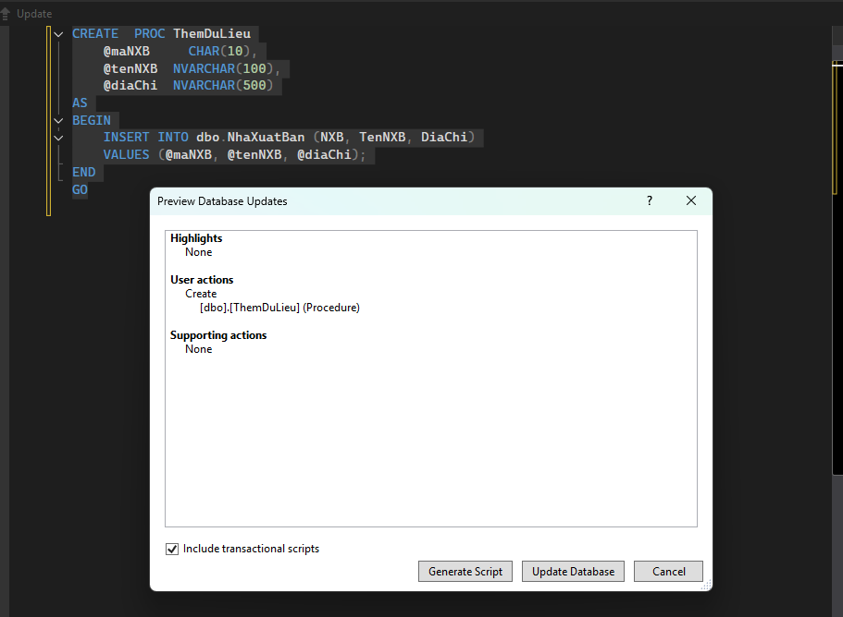

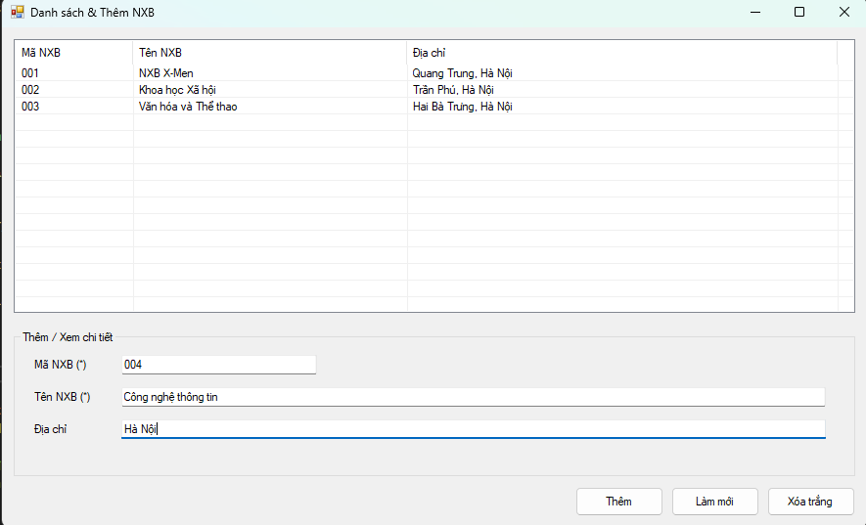

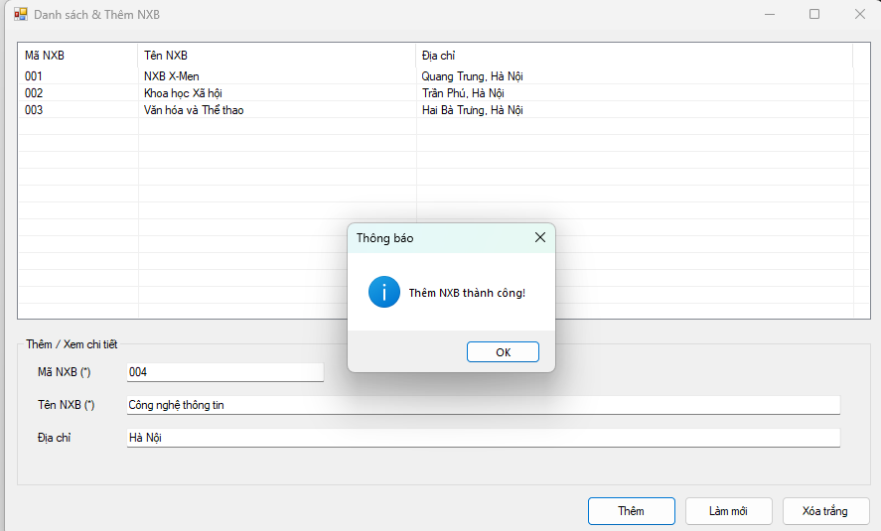

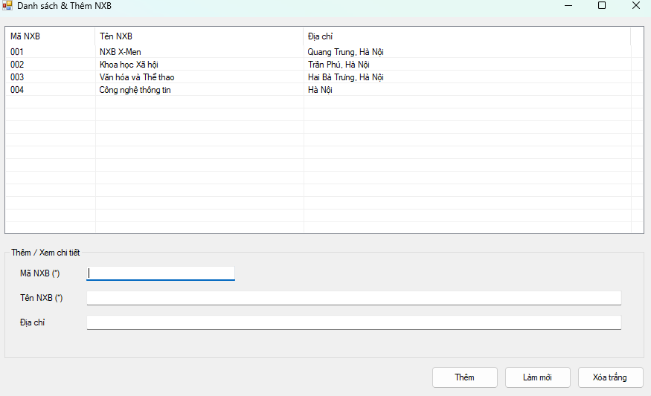

**Thực hành 3: Sửa dữ liệu cho bảng Nhà Xuất bản.**

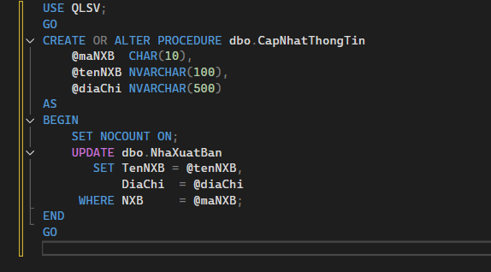

**Form3.cs**

using System;

using System.Data;

using System.Data.SqlClient;

using System.Windows.Forms;

namespace _1150080131_TranDuc_Lab6

{

public partial class Form3 : Form

{

// 👉 Sửa chuỗi kết nối đúng máy bạn

private readonly string _connStr =

@"Data Source=LAPTOP-LQGGA8E3\MSSQLSERVER2;

Initial Catalog=QLSV;

Integrated Security=True;

Encrypt=True;

TrustServerCertificate=True;";

private string _maHienTai; // NXB đang chỉnh

public Form3(string maNXB, string tenNXB, string diaChi)

{

InitializeComponent();

_maHienTai = (maNXB ?? "").Trim();

txtMaNXB.Text = _maHienTai; // khóa — không cho sửa

txtTenNXB.Text = tenNXB ?? "";

txtDiaChi.Text = diaChi ?? "";

this.AcceptButton = btnLuu;

this.CancelButton = btnHuy;

}

private void btnLuu_Click(object sender, EventArgs e)

{

if (string.IsNullOrWhiteSpace(txtMaNXB.Text) || txtMaNXB.Text.Trim().Length > 10)

{

MessageBox.Show("Mã NXB không hợp lệ.");

return;

}

if (string.IsNullOrWhiteSpace(txtTenNXB.Text))

{

MessageBox.Show("Vui lòng nhập Tên NXB.");

return;

}

try

{

using (var conn = new SqlConnection(_connStr))

{

conn.Open();

using (var cmd = new SqlCommand("CapNhatThongTin", conn))

{

cmd.CommandType = CommandType.StoredProcedure;

cmd.Parameters.Add(new SqlParameter("@maNXB", SqlDbType.Char, 10) { Value = _maHienTai });

cmd.Parameters.Add(new SqlParameter("@tenNXB", SqlDbType.NVarChar, 100) { Value = txtTenNXB.Text.Trim() });

cmd.Parameters.Add(new SqlParameter("@diaChi", SqlDbType.NVarChar, 500) { Value = (object)txtDiaChi.Text.Trim() ?? DBNull.Value });

int kq = cmd.ExecuteNonQuery();

if (kq > 0)

{

MessageBox.Show("Cập nhật thành công!", "Thông báo");

this.DialogResult = DialogResult.OK;

this.Close();

}

else

{

MessageBox.Show("Không có dòng nào được cập nhật.");

}

}

}

}

catch (SqlException ex)

{

MessageBox.Show("Lỗi SQL khi cập nhật:\n" + ex.Message, "Lỗi", MessageBoxButtons.OK, MessageBoxIcon.Error);

}

catch (Exception ex)

{

MessageBox.Show("Đã xảy ra lỗi:\n" + ex.Message, "Lỗi", MessageBoxButtons.OK, MessageBoxIcon.Error);

}

}

private void btnHuy_Click(object sender, EventArgs e)

{

this.DialogResult = DialogResult.Cancel;

this.Close();

}

}

}

**Form3.Desginer.cs**

namespace _1150080131_TranDuc_Lab6

{

partial class Form3

{

private System.ComponentModel.IContainer components = null;

private System.Windows.Forms.Label lblTitle;

private System.Windows.Forms.Label lblMa;

private System.Windows.Forms.Label lblTen;

private System.Windows.Forms.Label lblDiaChi;

private System.Windows.Forms.TextBox txtMaNXB;

private System.Windows.Forms.TextBox txtTenNXB;

private System.Windows.Forms.TextBox txtDiaChi;

private System.Windows.Forms.Button btnLuu;

private System.Windows.Forms.Button btnHuy;

protected override void Dispose(bool disposing)

{

if (disposing && (components != null)) components.Dispose();

base.Dispose(disposing);

}

private void InitializeComponent()

{

this.lblTitle = new System.Windows.Forms.Label();

this.lblMa = new System.Windows.Forms.Label();

this.lblTen = new System.Windows.Forms.Label();

this.lblDiaChi = new System.Windows.Forms.Label();

this.txtMaNXB = new System.Windows.Forms.TextBox();

this.txtTenNXB = new System.Windows.Forms.TextBox();

this.txtDiaChi = new System.Windows.Forms.TextBox();

this.btnLuu = new System.Windows.Forms.Button();

this.btnHuy = new System.Windows.Forms.Button();

this.SuspendLayout();

//

// lblTitle

//

this.lblTitle.AutoSize = true;

this.lblTitle.Font = new System.Drawing.Font("Segoe UI", 12F, System.Drawing.FontStyle.Bold);

this.lblTitle.Location = new System.Drawing.Point(16, 15);

this.lblTitle.Name = "lblTitle";

this.lblTitle.Size = new System.Drawing.Size(175, 21);

this.lblTitle.Text = "Cập nhật Nhà Xuất Bản";

//

// lblMa

//

this.lblMa.AutoSize = true;

this.lblMa.Location = new System.Drawing.Point(18, 58);

this.lblMa.Text = "Mã NXB (khóa)";

//

// lblTen

//

this.lblTen.AutoSize = true;

this.lblTen.Location = new System.Drawing.Point(18, 95);

this.lblTen.Text = "Tên NXB (*)";

//

// lblDiaChi

//

this.lblDiaChi.AutoSize = true;

this.lblDiaChi.Location = new System.Drawing.Point(18, 132);

this.lblDiaChi.Text = "Địa chỉ";

//

// txtMaNXB

//

this.txtMaNXB.Location = new System.Drawing.Point(110, 55);

this.txtMaNXB.MaxLength = 10;

this.txtMaNXB.ReadOnly = true; // khóa, không cho đổi

this.txtMaNXB.Size = new System.Drawing.Size(150, 23);

//

// txtTenNXB

//

this.txtTenNXB.Location = new System.Drawing.Point(110, 92);

this.txtTenNXB.MaxLength = 100;

this.txtTenNXB.Size = new System.Drawing.Size(360, 23);

//

// txtDiaChi

//

this.txtDiaChi.Location = new System.Drawing.Point(110, 129);

this.txtDiaChi.MaxLength = 500;

this.txtDiaChi.Multiline = true;

this.txtDiaChi.Size = new System.Drawing.Size(360, 80);

//

// btnLuu

//

this.btnLuu.Location = new System.Drawing.Point(294, 224);

this.btnLuu.Name = "btnLuu";

this.btnLuu.Size = new System.Drawing.Size(80, 30);

this.btnLuu.Text = "Lưu";

this.btnLuu.UseVisualStyleBackColor = true;

this.btnLuu.Click += new System.EventHandler(this.btnLuu_Click);

//

// btnHuy

//

this.btnHuy.Location = new System.Drawing.Point(390, 224);

this.btnHuy.Name = "btnHuy";

this.btnHuy.Size = new System.Drawing.Size(80, 30);

this.btnHuy.Text = "Hủy";

this.btnHuy.UseVisualStyleBackColor = true;

this.btnHuy.Click += new System.EventHandler(this.btnHuy_Click);

//

// Form3

//

this.AutoScaleDimensions = new System.Drawing.SizeF(7F, 15F);

this.ClientSize = new System.Drawing.Size(492, 271);

this.Controls.Add(this.btnHuy);

this.Controls.Add(this.btnLuu);

this.Controls.Add(this.txtDiaChi);

this.Controls.Add(this.txtTenNXB);

this.Controls.Add(this.txtMaNXB);

this.Controls.Add(this.lblDiaChi);

this.Controls.Add(this.lblTen);

this.Controls.Add(this.lblMa);

this.Controls.Add(this.lblTitle);

this.FormBorderStyle = System.Windows.Forms.FormBorderStyle.FixedDialog;

this.MaximizeBox = false;

this.MinimizeBox = false;

this.Name = "Form3";

this.StartPosition = System.Windows.Forms.FormStartPosition.CenterParent;

this.Text = "Sửa NXB";

this.ResumeLayout(false);

this.PerformLayout();

}

}

}

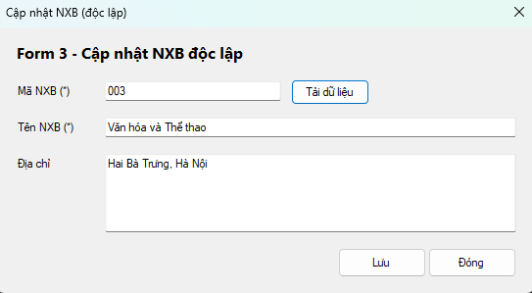

**Thực hành 4: Xóa dữ liệu cho bảng Nhà xuất bản.**

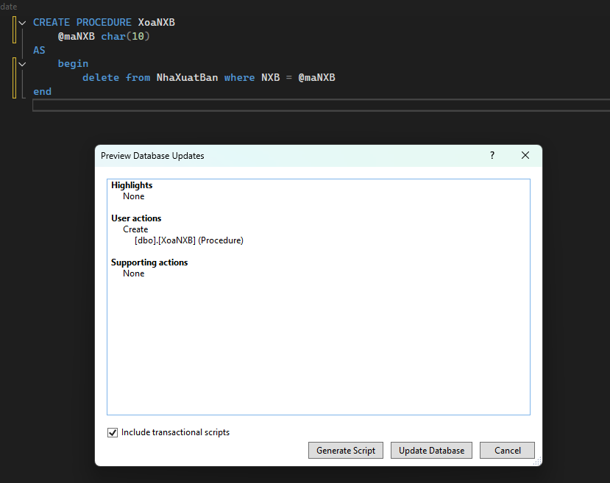

**Form4.cs**

using System;

using System.Data;

using System.Data.SqlClient;

using System.Windows.Forms;

namespace _1150080131_TranDuc_Lab6

{

public partial class Form4 : Form

{

// 👉 Sửa chuỗi kết nối cho đúng máy bạn

private readonly string _connStr =

@"Data Source=LAPTOP-LQGGA8E3\MSSQLSERVER2;

Initial Catalog=QLSV;

Integrated Security=True;

Encrypt=True;

TrustServerCertificate=True;";

private SqlConnection _conn;

public Form4()

{

InitializeComponent();

lsvDanhSach.FullRowSelect = true;

lsvDanhSach.GridLines = true;

lsvDanhSach.View = View.Details;

}

private void OpenConn()

{

if (_conn == null) _conn = new SqlConnection(_connStr);

if (_conn.State != ConnectionState.Open) _conn.Open();

}

private void CloseConn()

{

if (_conn != null && _conn.State == ConnectionState.Open) _conn.Close();

}

private void Form4_Load(object sender, EventArgs e)

{

LoadNXB();

}

private void LoadNXB()

{

try

{

OpenConn();

// Ưu tiên dùng proc HienThiNXB nếu bạn đã tạo; nếu chưa có, dùng SELECT

using (var cmd = new SqlCommand("HienThiNXB", _conn))

{

cmd.CommandType = CommandType.StoredProcedure;

using (var rd = cmd.ExecuteReader())

{

lsvDanhSach.Items.Clear();

while (rd.Read())

{

// Giả sử thứ tự cột: NXB, TenNXB, DiaChi

var it = new ListViewItem(rd.GetString(0).Trim());

it.SubItems.Add(rd.GetString(1));

it.SubItems.Add(rd.IsDBNull(2) ? "" : rd.GetString(2));

lsvDanhSach.Items.Add(it);

}

}

}

}

catch // nếu chưa có proc, fallback sang SELECT

{

try

{

using (var cmd2 = new SqlCommand(

"SELECT NXB, TenNXB, DiaChi FROM dbo.NhaXuatBan ORDER BY NXB", _conn))

using (var rd = cmd2.ExecuteReader())

{

lsvDanhSach.Items.Clear();

while (rd.Read())

{

var it = new ListViewItem(rd.GetString(0).Trim());

it.SubItems.Add(rd.GetString(1));

it.SubItems.Add(rd.IsDBNull(2) ? "" : rd.GetString(2));

lsvDanhSach.Items.Add(it);

}

}

}

catch (Exception ex)

{

MessageBox.Show("Không tải được danh sách:\n" + ex.Message,

"Lỗi", MessageBoxButtons.OK, MessageBoxIcon.Error);

}

}

finally { CloseConn(); }

ClearDetail();

}

private void lsvDanhSach_SelectedIndexChanged(object sender, EventArgs e)

{

if (lsvDanhSach.SelectedItems.Count == 0) return;

var it = lsvDanhSach.SelectedItems[0];

txtMaNXB.Text = it.SubItems[0].Text;

txtTenNXB.Text = it.SubItems[1].Text;

txtDiaChi.Text = it.SubItems[2].Text;

}

private void btnLamMoi_Click(object sender, EventArgs e) => LoadNXB();

private void btnXoa_Click(object sender, EventArgs e)

{

string ma = txtMaNXB.Text.Trim();

if (string.IsNullOrWhiteSpace(ma))

{

MessageBox.Show("Hãy chọn một NXB để xóa.");

return;

}

var yes = MessageBox.Show(

$"Bạn chắc chắn muốn xóa NXB [{ma}]?\nThao tác này không thể hoàn tác.",

"Xác nhận xóa", MessageBoxButtons.YesNo, MessageBoxIcon.Warning);

if (yes != DialogResult.Yes) return;

try

{

OpenConn();

using (var cmd = new SqlCommand("XoaNXB", _conn))

{

cmd.CommandType = CommandType.StoredProcedure;

cmd.Parameters.Add(new SqlParameter("@maNXB", SqlDbType.Char, 10) { Value = ma });

int kq = cmd.ExecuteNonQuery();

if (kq > 0)

MessageBox.Show("Đã xóa thành công.", "Thông báo");

else

MessageBox.Show("Không có dòng nào bị xóa (mã không tồn tại?).");

}

}

catch (SqlException ex)

{

// Có thể vướng khóa ngoại (NXB đang được tham chiếu bởi bảng Sách)

MessageBox.Show("Lỗi SQL khi xóa:\n" + ex.Message,

"Lỗi", MessageBoxButtons.OK, MessageBoxIcon.Error);

}

catch (Exception ex)

{

MessageBox.Show("Đã xảy ra lỗi:\n" + ex.Message,

"Lỗi", MessageBoxButtons.OK, MessageBoxIcon.Error);

}

finally

{

CloseConn();

LoadNXB(); // refresh danh sách

}

}

private void btnDong_Click(object sender, EventArgs e) => this.Close();

private void ClearDetail()

{

txtMaNXB.Clear();

txtTenNXB.Clear();

txtDiaChi.Clear();

lsvDanhSach.SelectedItems.Clear();

}

}

}

**Form4.Desginer.cs**

namespace _1150080131_TranDuc_Lab6

{

partial class Form4

{

private System.ComponentModel.IContainer components = null;

private System.Windows.Forms.ListView lsvDanhSach;

private System.Windows.Forms.ColumnHeader colMa;

private System.Windows.Forms.ColumnHeader colTen;

private System.Windows.Forms.ColumnHeader colDiaChi;

private System.Windows.Forms.GroupBox grpChiTiet;

private System.Windows.Forms.Label lblMa;

private System.Windows.Forms.Label lblTen;

private System.Windows.Forms.Label lblDiaChi;

private System.Windows.Forms.TextBox txtMaNXB;

private System.Windows.Forms.TextBox txtTenNXB;

private System.Windows.Forms.TextBox txtDiaChi;

private System.Windows.Forms.Button btnXoa;

private System.Windows.Forms.Button btnLamMoi;

private System.Windows.Forms.Button btnDong;

protected override void Dispose(bool disposing)

{

if (disposing && (components != null)) components.Dispose();

base.Dispose(disposing);

}

private void InitializeComponent()

{

this.lsvDanhSach = new System.Windows.Forms.ListView();

this.colMa = new System.Windows.Forms.ColumnHeader();

this.colTen = new System.Windows.Forms.ColumnHeader();

this.colDiaChi = new System.Windows.Forms.ColumnHeader();

this.grpChiTiet = new System.Windows.Forms.GroupBox();

this.lblMa = new System.Windows.Forms.Label();

this.lblTen = new System.Windows.Forms.Label();

this.lblDiaChi = new System.Windows.Forms.Label();

this.txtMaNXB = new System.Windows.Forms.TextBox();

this.txtTenNXB = new System.Windows.Forms.TextBox();

this.txtDiaChi = new System.Windows.Forms.TextBox();

this.btnXoa = new System.Windows.Forms.Button();

this.btnLamMoi = new System.Windows.Forms.Button();

this.btnDong = new System.Windows.Forms.Button();

this.grpChiTiet.SuspendLayout();

this.SuspendLayout();

//

// lsvDanhSach

//

this.lsvDanhSach.Anchor = ((System.Windows.Forms.AnchorStyles)(((System.Windows.Forms.AnchorStyles.Top | System.Windows.Forms.AnchorStyles.Left)

| System.Windows.Forms.AnchorStyles.Right)));

this.lsvDanhSach.Columns.AddRange(new System.Windows.Forms.ColumnHeader[] {

this.colMa, this.colTen, this.colDiaChi});

this.lsvDanhSach.Location = new System.Drawing.Point(12, 12);

this.lsvDanhSach.MultiSelect = false;

this.lsvDanhSach.Name = "lsvDanhSach";

this.lsvDanhSach.Size = new System.Drawing.Size(820, 270);

this.lsvDanhSach.TabIndex = 0;

this.lsvDanhSach.UseCompatibleStateImageBehavior = false;

this.lsvDanhSach.View = System.Windows.Forms.View.Details;

this.lsvDanhSach.SelectedIndexChanged += new System.EventHandler(this.lsvDanhSach_SelectedIndexChanged);

//

// column headers

//

this.colMa.Text = "Mã NXB"; this.colMa.Width = 120;

this.colTen.Text = "Tên NXB"; this.colTen.Width = 260;

this.colDiaChi.Text = "Địa chỉ"; this.colDiaChi.Width = 420;

//

// grpChiTiet

//

this.grpChiTiet.Anchor = ((System.Windows.Forms.AnchorStyles)(((System.Windows.Forms.AnchorStyles.Bottom | System.Windows.Forms.AnchorStyles.Left)

| System.Windows.Forms.AnchorStyles.Right)));

this.grpChiTiet.Controls.Add(this.txtDiaChi);

this.grpChiTiet.Controls.Add(this.txtTenNXB);

this.grpChiTiet.Controls.Add(this.txtMaNXB);

this.grpChiTiet.Controls.Add(this.lblDiaChi);

this.grpChiTiet.Controls.Add(this.lblTen);

this.grpChiTiet.Controls.Add(this.lblMa);

this.grpChiTiet.Location = new System.Drawing.Point(12, 298);

this.grpChiTiet.Name = "grpChiTiet";

this.grpChiTiet.Size = new System.Drawing.Size(820, 130);

this.grpChiTiet.TabIndex = 1;

this.grpChiTiet.TabStop = false;

this.grpChiTiet.Text = "Chi tiết (dòng được chọn)";

//

// labels

//

this.lblMa.AutoSize = true; this.lblMa.Location = new System.Drawing.Point(18, 28); this.lblMa.Text = "Mã NXB";

this.lblTen.AutoSize = true; this.lblTen.Location = new System.Drawing.Point(18, 58); this.lblTen.Text = "Tên NXB";

this.lblDiaChi.AutoSize = true; this.lblDiaChi.Location = new System.Drawing.Point(18, 88); this.lblDiaChi.Text = "Địa chỉ";

//

// textboxes

//

this.txtMaNXB.Location = new System.Drawing.Point(90, 25); this.txtMaNXB.ReadOnly = true; this.txtMaNXB.Size = new System.Drawing.Size(180, 23);

this.txtTenNXB.Location = new System.Drawing.Point(90, 55); this.txtTenNXB.ReadOnly = true; this.txtTenNXB.Size = new System.Drawing.Size(710, 23);

this.txtDiaChi.Location = new System.Drawing.Point(90, 85); this.txtDiaChi.ReadOnly = true; this.txtDiaChi.Size = new System.Drawing.Size(710, 23);

//

// btnXoa

//

this.btnXoa.Anchor = System.Windows.Forms.AnchorStyles.Bottom;

this.btnXoa.Location = new System.Drawing.Point(548, 436);

this.btnXoa.Name = "btnXoa";

this.btnXoa.Size = new System.Drawing.Size(90, 30);

this.btnXoa.TabIndex = 2;

this.btnXoa.Text = "Xóa";

this.btnXoa.UseVisualStyleBackColor = true;

this.btnXoa.Click += new System.EventHandler(this.btnXoa_Click);

//

// btnLamMoi

//

this.btnLamMoi.Anchor = System.Windows.Forms.AnchorStyles.Bottom;

this.btnLamMoi.Location = new System.Drawing.Point(646, 436);

this.btnLamMoi.Name = "btnLamMoi";

this.btnLamMoi.Size = new System.Drawing.Size(90, 30);

this.btnLamMoi.TabIndex = 3;

this.btnLamMoi.Text = "Làm mới";

this.btnLamMoi.UseVisualStyleBackColor = true;

this.btnLamMoi.Click += new System.EventHandler(this.btnLamMoi_Click);

//

// btnDong

//

this.btnDong.Anchor = System.Windows.Forms.AnchorStyles.Bottom;

this.btnDong.Location = new System.Drawing.Point(744, 436);

this.btnDong.Name = "btnDong";

this.btnDong.Size = new System.Drawing.Size(90, 30);

this.btnDong.TabIndex = 4;

this.btnDong.Text = "Đóng";

this.btnDong.UseVisualStyleBackColor = true;

this.btnDong.Click += new System.EventHandler(this.btnDong_Click);

//

// Form4

//

this.AutoScaleDimensions = new System.Drawing.SizeF(7F, 15F);

this.ClientSize = new System.Drawing.Size(844, 478);

this.Controls.Add(this.btnDong);

this.Controls.Add(this.btnLamMoi);

this.Controls.Add(this.btnXoa);

this.Controls.Add(this.grpChiTiet);

this.Controls.Add(this.lsvDanhSach);

this.MinimumSize = new System.Drawing.Size(760, 480);

this.Name = "Form4";

this.StartPosition = System.Windows.Forms.FormStartPosition.CenterScreen;

this.Text = "Xóa Nhà Xuất Bản";

this.Load += new System.EventHandler(this.Form4_Load);

this.grpChiTiet.ResumeLayout(false);

this.grpChiTiet.PerformLayout();

this.ResumeLayout(false);

}

}

}

